51.2.2.22 Sales order lines – assistents
This function is about all open articles in sales orders (SO).
- Overdue – means we missed Due Date, is marked as (e.g. we didn´t confirmed SO and thereofre missed Due Date, or warehouse was not able to print PDL for some reason, ….)
- Sort Name – name of customer (searching term)
- Sold to Party – buying number
- Ship to Party – delivery number
- Rest – when there is no Qties or not enough in full rolls, then warehouseman put SO into res, means we have to check availabilty again, set new term and inform our customer about delay
- Sales Order – HRX number
- Purchase Order – customer´s number
- Dute Date – date when we ship the goods (boxes, pallets)
- Confirmed – we have to confirm each order, only then our warehouse is able to print PreShipper (PDL) and prepare the goods
- Remark – our comments
- Product Line – article group (PG 1010 stocked, PG 1310 slitted, PG 1510 extruded, etc.)
- Ln – line position in SO
- Item Number – article number
- Description 1 - edge or product description
- Description 2 – edge dimension or another info about product
- Quantity Ordered – required Qties
- Quantity Opened – not processed
- Quantity on Stock – stocked Qties
- Quanity on SO – Qties on all SO
- Line Comments – comments on line
- Scanned – status of PDL
- Updated – status of PDL
- PreShipper – PDL number
- Shipper Confirmed – status of DL (delivery note)
- Shipper – DL number
- Invoice - number
- Roll – length of roll
- Box – amount in 1 box
- Neight weight (by open qty) – weight of goods without a box
- Entered by – who processed SO

These above are the most important for me. There are also another fields, you can keep them opened (not hidden) as well. It is up to you and your needs.

Please, use the correct number range withing your NL domain (4 = domestic, 6 = export).

By below settings you can find all open items which havenť been confirmed yet.

Check this on daily basis.
- There can be new incoming lines from e-shop.
- There can be some forgotten lines which were not confirmed by mistake.
- There can be some lines/orders waiting for payment in advance.
- There can be some pending lines/orders waiting for some reason/specification.

Below you can see all uncofirmed lines which need to be checked and confirmed and set Due Date on them.

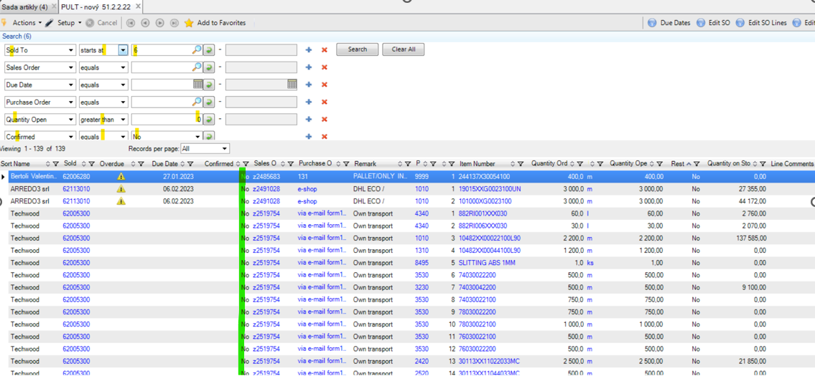

You can use your own filters, more specific, eg. based on particular Sold to party, etc.

By below settings you can find all open items which have been confirmed already.

Check this on daily basis.

- Lines for which Due Date have been set, but now the lines are in Rests.
- Means that we have already confirmed Due Date, but for some reason our warehouse didn´t confirm the item (no Qties in stock, low Qties in stock, short rolls, etc.)
- When guys put the line into Rest = Due Date dissapiers and we need to set it again, othewise it will not be processed by our warehouse and sent to our customer.

- Lines for which Due Dates haven´t been set yet = no Rests.
- Typically when there is atypical purchased item and I need our purchaser to buy it. Purchaser need to see an item in their plan (line must be confired), but we still do not have Due Date (it takes few days to get a term from our supplier).
- Or when you want/need to „block“ an item in stock while you are waiting for some specification from a customer or from a sales manager.
- Or in case that you confirmed a line, but you block it against PDL printing in your warehouse. If there is no Due Date = no PDL can be printed.

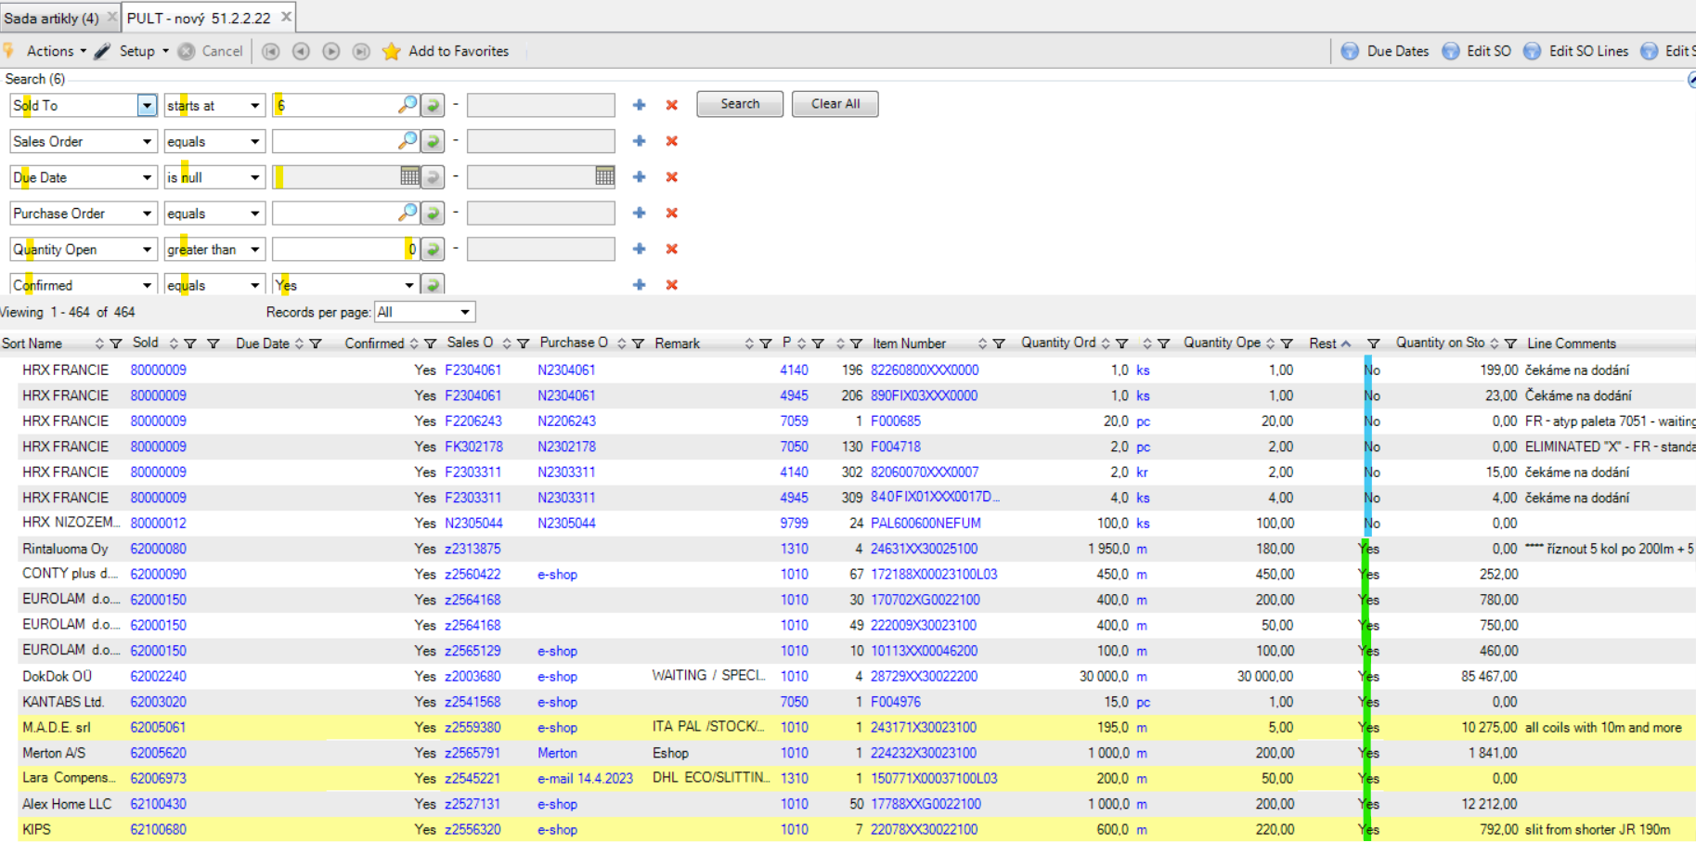

By below settings you can find all open items with old/not current Due Date.

There can be different cases what we can see here.
Basically it shows all old Due Dates since today towards to the past.
As you will handle with all sales orders, you will know why it is so and so …

Check this on regular basis and finalize the lines properly.
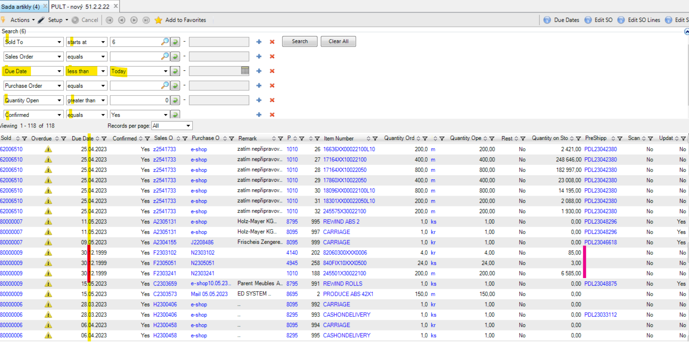

If there is old/passed Due Date + Rest = YES.
- Sometimes it can happen when a warehouseman put a line into Rest/YES.
- Due Date still exist when putting item into rest and this is mistake. Standardly Due Date should dissapier in this case.
- You need to check such items. Ideally on daily basis.
- If you don´t check it, guys will not print PDLs for such lines, because they print PDL only base on current day. And therefore such lines will be lost in the abyss of history. Customer is waiting, but nothing is on the way to their place.
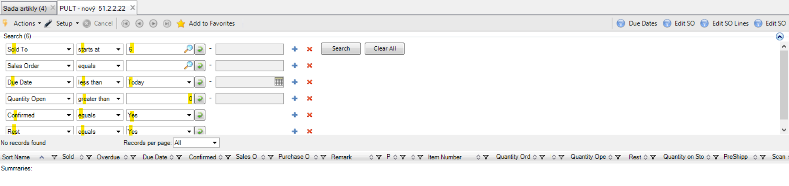
Currently there is nothing like this, so I cannot show you.

